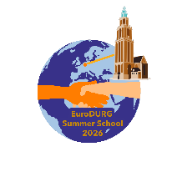
Registration form: ISPE-EuroDURG Drug Utilisation Research Summer School Groningen
24th–28th August 2026 in Groningen, the Netherlands

Please send the completed form (as attachment) to Kimberly Kleefman: k.r.kleefman@rug.nl
Name

Email-address

Affiliation
(name and details of University/Institution/Workplace)

Are you a PhD student?
(yes/no)
Do you have experience in drug utilization research?
(yes/no)
How many years of experience in drug utilization research do you have?
Please explain briefly your motivation to participate in the Summer School.

Do you want to attend the International DUR Symposium on Friday 28th 2026 (free access)
(yes/no)
Do you have any special requirements we need to be aware of?

Please note: Upon receipt of this form, we will send you information about payment of the fee. Upon receipt of the payment, you will receive the final confirmation to participate in the summer school.

